**Assignment 3**

**1.Waterfall SDLC Model:**

The water model is one of the oldest and most straightforward approaches to software development.

* Phases:

▪ Requirements: Gather requirements from stakeholders and analyze them to understand the project scope and objectives.

▪ Design: Create a detailed design document outlining software architecture, user interface, and system components.

▪ Development: Implement the software based on design specifications, including unit testing.

▪ Testing: Test the software as a whole to ensure it meets requirements and is defect-free.

▪ Deployment: Deploy the tested and approved software to the production environment.

▪ Maintenance: Fix issues post-deployment and ensure ongoing compliance with requirements.

* Advantages:

▪ Simplicity: Linear and sequential nature makes it easy to understand and implement.

* Disadvantages:

▪ Rigidity: Changes are difficult once a phase is completed.

▪ Limited adaptability: Not suitable for dynamic or evolving requirements.

* Applicability: Well-suited for stable projects with clear requirements.

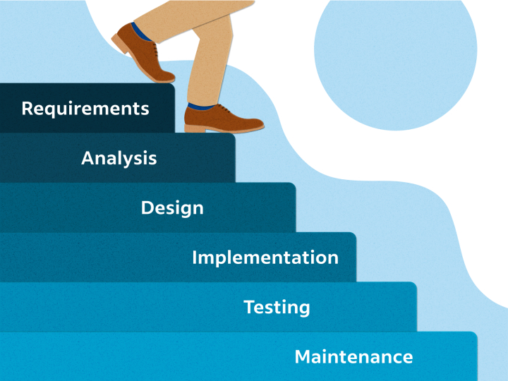

**2.Agile SDLC Model:**

Agile is not a specific methodology but rather a set of principles and values outlined in the Agile Manifesto. The Agile Manifesto prioritizes individuals and interactions, working solutions, customer collaboration, and responding to change over rigid processes and documentation

* Phases:

▪ Sprints: Short development cycles with continuous feedback and adjustments.

* Advantages:

▪ Adaptability: Easily accommodates changing requirements.

▪ Collaboration: Frequent communication among team members.

* Disadvantages:

▪ Complexity: Requires active participation and coordination.

▪ Documentation: Minimal formal documentation

.

* Applicability: Ideal for dynamic projects where requirements evolve.

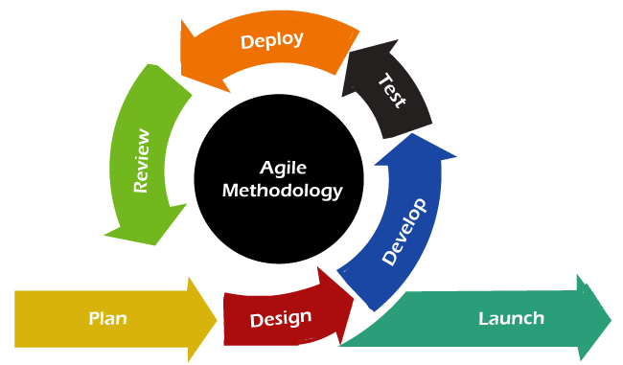

1. **Spiral SDLC Model:**

The Spiral model combines the idea of iterative development with the systematic aspects of the Waterfall model. It is based on the concept of a spiral, with each loop representing a phase in the software development process. The model is inherently risk-driven, meaning that risks are continuously assessed and addressed throughout the development life cycle.

* Phases:

▪ Planning: Define objectives, constraints, and risks.

▪ Engineering: Develop and test the software.

▪ Evaluation: Review progress and assess risks.

▪ Risk Analysis: Identify and address potential risks.

* Advantages:

▪ Risk Management: Explicit focus on risk assessment.

▪ Flexibility: Iterative approach allows for adjustments.

* Disadvantages:

▪ Complexity: Requires skilled project management.

▪ Time-Consuming: Multiple iterations can extend the timeline.

* Applicability: Suitable for large, complex projects with high risks.

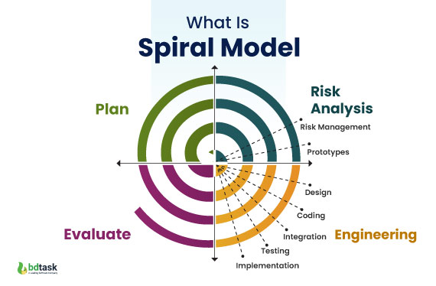

**4.V-Model (Verification and Validation Model):**

The V-Models, also known as the Verification and Validation models, is an extension of the traditional Waterfall models. It introduces a parallel testing phase for each corresponding development stage, forming a V-shaped diagram. Let’s delve into the key principles that underpin the V-Models.

* Phases:

▪ Requirements: Define requirements.

▪ Design: Create system design.

▪ Coding: Implement the design.

▪ Testing: Verify and validate at each level.

* Advantages:

▪ Thorough Testing: Rigorous testing throughout the process.

▪ Traceability: Clear mapping between requirements and testing.

* Disadvantages:

▪ Rigidity: Similar to Waterfall in terms of inflexibility.

▪ Documentation Overhead: Detailed documentation required.

* Applicability: Well-suited for critical systems with strict quality requirements.

